我的教育專欄(217)孩子可能快樂學習嗎

李家同

最近，有一位偏鄉的國中老師向我埋怨，他說他的學生很用功，可是在英文上面都有嚴重的挫折感，因為英文會考題目中，有長篇閱讀的文章，對於國中生而言，要看這種文章實在是很不應該的。他們第一個反應，就是害怕。
我本人也對這種考題害怕，我希望教育部的官員看民國43年的高中入學考題，大官們會發現那時候的考題容易的多，我就是在那一年考上高中的。當年的國中生都是經由考試進去的，所以我們都有一定的程度，可是考題比較容易，現在國中生是免試入學的，考題反而難了。
教改最響亮的口號莫過於快樂學習。看了下面這些考題以後，教育部的官員憑憑良心看，孩子們會快樂嗎？當然，有些孩子是快樂的，因為他們早就放棄了。以下是近幾年的一些英文會考考題，每一次的英文會考，這種題目總要有至少五個題組，也就是說孩子們要看五篇這種文章，然後才能作答。
就以第一篇文章為例，我問各位，這到底講什麼？一下子說Lucy和黑暗的廚房有關，然後又提到可怕的風聲，可是又提到了玩具狗，最恐怖的是以下這句話：And pulling me down to their house under the ground，這句話使我毛骨悚然，有趣的是，絕大多數學生，根本不知道這句話是什麼意思，年紀小的孩子是不太了解何謂their house under the ground的。我曾經寫信去問教育部的官員，Who is Lucy?，回信來了，我怎麼樣也看不懂。我也曾經給五位外文系的教授看這篇文章，大家一致搖頭。
很多題目，不像在考英文，而是在考智力測驗，我真的不知道出題的老師是不是英文老師？還是智力測驗的老師？
請大家看看下面的考題，請回答我的問題，孩子們可以快樂學習嗎？
一、(105年會考 23-24題)
The wind keeps blowing.
The door keeps opening.
Will you be with me, my dear Lucy,
When I look for candy
Down there in the dark, dark kitchen?
The wind keeps crying.
The door keeps shaking.
Will you be with me, my dear Lucy,
When I pick up my toy puppy
Out there on the high, high balcony?
Wish you could always be with me
And make them go away with your Do-Re-Me.
I remember last Halloween
They ran away when you started to sing,
“Dear Tommy, my little king,
Close your eyes and have a sweet dream.”
So please stay with me and sing
To stop them kicking the door, riding the wind,
And pulling me down to their house under the ground.
They’ll go away if you sing here for me,
In a voice that gets a black cat’s hair standing,
The strongest legs shaking, and the window glass breaking.
(ideas from Matthew Sweeney’s poem)
( ) 23. Which is most likely true about the speaker in the reading ?
(A) He thinks a black cat is hiding somewhere in the house.
(B) He feels lonely because he is the only child in his family.
(C) He is looking for something he left somewhere in the house.
(D) He is afraid of being by himself when he feels ghosts around.

( ) 24. What can we learn about Lucy in the reading ?
(A) She keeps opening the door.
(B) Her voice makes the speaker feel safe.
(C) Her candy was hidden in the kitchen.
(D) She was away from home last Halloween.

二、(103年會考 33-35題)
Do you eat meat? Well, if you do, then you might find our next news interesting. A study says that the world has a ___33___ need for meat. In 1960, the world ate 64 million tonnes of meat, about 21 kg for each person. In 2007, the number rose to 268 million tonnes, about 40 kg for each person. At the same time, ___34___. In the 1960s, beef was high on the menu. Of the meat that was eaten, 40% was beef. In 2007, pork became the star. Poultry also became popular, going up from 12% to 32%, thanks to people’s worries about their health these years. And ___35___? You’re guessing the U.S.A., right? The answer is Luxembourg! In 2007, each Luxembourger ate about 137 kg of meat! Second to Luxembourgers are Americans. In 2007, each American ate about 126 kg! Now, enough with the numbers. I’m playing you a song called Currywurst. The singer sings his love for the meat dish of the same name. Enjoy!
( ) 33. (A) falling
(B) special
(C) growing
(D) common
( ) 34. (A) we have changed our way of cooking meat
(B) new kinds of meat have come on the market
(C) there have been changes in the list of favorite meats
(D) doctors have been worried that we eat too much meat
( ) 35. (A) where does the world’s best meat come from
(B) which country is the world’s biggest meat maker
(C) where can you eat the world’s most delicious meat
(D) which country uses up the most meat for each person

三、(105年會考 32-34題)
Since the first case of “Cow Cold” was reported in Kirk State in June, this killer cold has moved up north faster than we thought it would. By July, almost every part of the country had been attacked by Cow Cold. In only two months, the number of dead cows has risen to 5,000. Though Cow Cold started in the south, the east of the country is the worst hit area. By this week, 80% of the farms in Osten State have reported cases of Cow Cold.
The sale of milk in Osten State has slumped because of Cow Cold. Before Cow Cold, the sale of milk in Osten State was $2.5 million each week; now it is less than $500,000.
Odin State is the only area in the north without cases of Cow Cold. Before we know how to deal with Cow Cold, we can only hope Odin State will be lucky enough not to experience the power of this killer cold.
(Elaine Baker, City Post)

（ ） 32. What can we learn from the news report?
(A) How to deal with Cow Cold.
(B) Whether people may catch Cow Cold.
(C) How fast Cow Cold has hit the country.
(D) How to find out if cows have Cow Cold.

（ ） 33. Which map will most likely appear with the above news report? likely 可能

(A) (B) (C) (D)
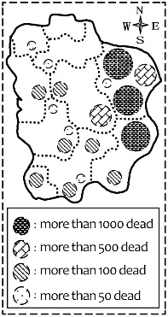 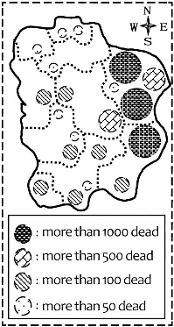 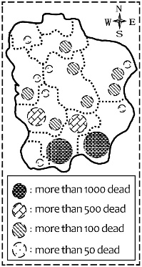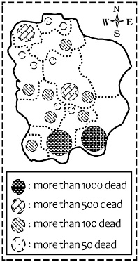

（ ） 34. If a store’s sales keep slumping, what would the sales chart look like?
chart 圖表
(A) (B) (C) (D)
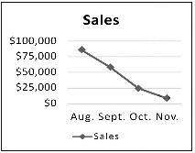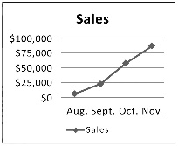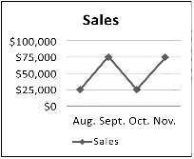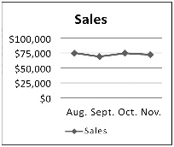

四、(106年會考 38-41題)

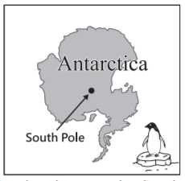

Englishman Robert Scott is known for leading two trips to Antarctica. The first one made him a star; the second ___38___.
After his first successful trip, Scott decided to be the first person to stand on the South Pole. However, ___39___. He would be in a race with Roald Amundsen, from Norway. Both left their countries by ship in June of 1910 and arrived in Antarctica in January of 1911.
About ten months later, both teams started their trips down to the South Pole. ___40___. Amundsen’s team used dogs, and Scott’s team used horses. Because horses weren’t good at traveling on snow, it took Scott’s team 77 days to arrive at the South Pole. They got there on January 17, 1912, and were surprised to find that Amundsen was ahead of them. The news hit Scott very hard, but what he didn’t know was that ___41___. His team began their long trip home with broken hearts. After days of terrible weather and little food, Scott lost his men one after another, and he himself was the last one to meet the end of his life. No one on his team lived to go back home and tell their story. It was only learned through Scott’s diary.

( ) 38. (A) hurt his health
(B) opened his eyes
(C) cost him his life
(D) made his dream come true

( ) 39. (A) he didn’t want to take this trip with others
(B) he wasn’t the only one who had this dream
(C) he wouldn’t let anyone else take his prize away
(D) he couldn’t miss the chance to make his country proud
( ) 40. (A) And Scott used a popular way for his men to travel fast
(B) But there were problems to deal with before they traveled
(C) But Amundsen didn’t know better about animals than Scott
.(D) And their ways of traveling decided which team would win
( ) 41. (A) there was still hope
(B) no one ever believed him
(C) the worst had not come yet
(D) Amundsen had not been honest

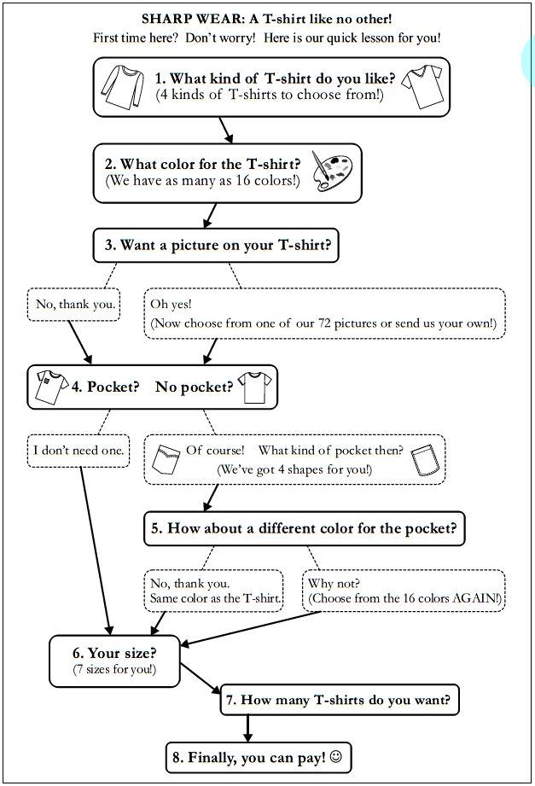
五、(107年會考 25-26題)
（ C ）25. What is the quick lesson of SHARP WEAR about?
(A) How to get to one of SHARP WEAR’s stores.
(B) How to send back a T-shirt to SHARP WEAR.
(C) How to shop for a T-shirt from SHARP WEAR.
(D) How to take care of a T-shirt from SHARP WEAR.

（ B ）26. What can we learn about SHARP WEAR?
(A) You have to order at least four T-shirts each time.
(B) You can choose from sixteen colors for both the T-shirt and the pocket.
(C) Some of the T-shirts have pictures on both the front side and the back side.
(D) T-shirts in the wrong sizes cannot be sent back if they have pictures or pockets on them.

六、(107年會考 29-31題)
When we get wet, we need a towel to get ourselves dry. When a dog gets wet, all it needs is to shake its body. A study in 2010 showed that a wet dog can throw off half the water on its body by shaking for less than a second. In fact, this common act of dogs works better than a washing machine.
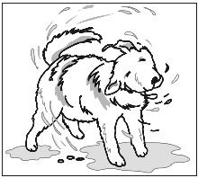
The study found that animal shaking begins with the head and ends with the tail. During a shake, the animal’s head, body and skin all move. Smaller animals must shake faster than bigger animals to get water off. For example, in one second, a rat can shake 18 times, a dog 6 times, and a bear 4 times. Bigger animals can get their bodies dry with fewer shakes.
For animals, shaking is not just about getting themselves dry. It is also about saving their lives. Being wet makes animals heavier, and that makes it harder to run. In the animal world, how fast an animal can run often decides whether it will live or not. Maybe that’s why the “wet-dog shake” has become a common habit of many animals. skin 皮膚

（ D ）29. What does the reading say about shaking?
(A) Different animals’ shaking begins with different body parts.
(B) Shaking is a way that animals use to make other animals scared.
(C) Animals that are not kept as pets do the shaking better than those that are.
(D) Shaking themselves dry may help animals run faster in dangerous moments.

（ D ）30. What can we learn from the reading?
(A) The animal’s tail can help it run more quickly and easily.
(B) Some animals shake more than they need to get water off.
(C) The idea of washing machines came from the shaking of dogs.
(D) Larger animals get themselves drier at each shake than smaller animals.

（ B ）31. The four pictures below show how fast tigers, cats and mice can shake. From the reading, which picture is most likely correct? likely 可能
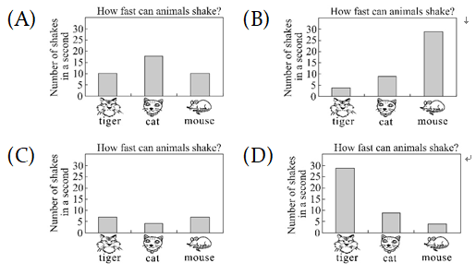

七、(108年會考 18-19題)

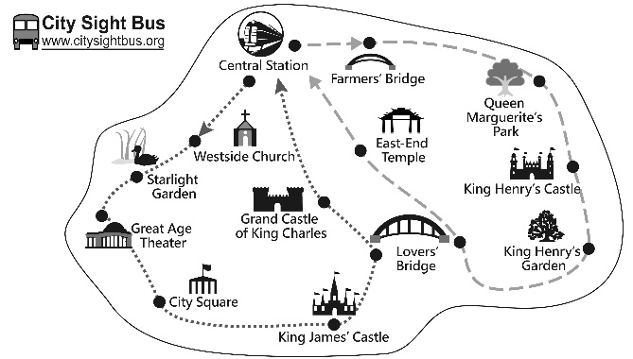

OPENING HOURS
◆ High Season (April to September): 9:00 – 18:00 every day
◆ Low Season (October to March): 9:00 – 17:00 every day
TICKET PRICES
◆ Line A (): $20 each person
◆ Line B (): $18 each person
THINGS YOU SHOULD KNOW
◆ Buses for both lines leave every hour from Central Station.
◆ Line A takes one hour; Line B takes 50 minutes.
◆ If you are taking your pet with you, please buy a seat for it at half price.
◆ Save 10% if you buy tickets on the Internet.
◆ Save 10% if you buy tickets for both lines.
◆ Go to www.citysightbus.org for more information.
（ ）18 .Which is true about City Sight Bus tickets?
(A) It costs less to buy tickets on the Internet.
(B) People must pay the full ticket price for a pet.
(C) Tickets are more expensive in the high season.
(D) People save 10% if they buy two tickets for the same line.

（ ）19. Which is true about the bus lines?
(A) Line B takes more time.
(B) Both lines cross Farmers’ Bridge.
(C) Both lines leave from Central Station.
(D) There are more gardens to see on Line A.

八、(108年會考 26-28題)
Here are two pieces of news that Annie collected for her report.
Papier-mâché is works of art that are made of paper. In Taiwan, it is known as zhizha and is usually burned as a gift for dead people. Taiwan’s papier-mâché is dying because it is not much needed now. However, this dying art won a Frenchman’s heart when he visited the island. He then invited one of the papier-mâché shops, Hsin Hsin Paper Offering Store, to show their beautiful works in France. The shop owner’s son also used papier- mâché in a way that no one ever thought of—making a movie with it.

Stan Lai is very important in Taiwan’s theater. He brought changes to Chinese theater art of the old days to make it closer to our life experiences and easier to understand. One of his most famous works is That Evening, We Performed Crosstalk (1985). It was such a smash hit that people became interested again in xiangsheng, a show of funny talk between two actors. This art used to be a hobby that only a few people shared, but Lai has opened a bigger market for it. Now it has fans across all ages.

（ ）26. What idea is talked about in both pieces of news?
(A) More young people need to join in making art.
(B) People’s ways of enjoying art change with time.
(C) Bringing important art works to Taiwan from abroad.
(D) Giving new life to old arts that were almost forgotten.

（ ）27. What does it mean when something is a smash hit?
(A) It is old.
(B) It is successful.
(C) It is foreign.
(D) It is useful.

（ ）28. What do we know from the news?
(A) Lai has taught xiangsheng in many schools.
(B) Lai often puts his own life stories into his art works.
(C) The owner of Hsin Hsin Paper Offering Store is a Frenchman.
(D) People do not burn papier-mâché for dead people as often as before.

