我的教育專欄(207)博幼大專院校生的英文程度

李家同

我們博幼基金會對孩子只教到國中畢業，他們國中畢業以後四分五散，到各個高中職念書，可是我們還是和這些學生保持聯絡，每一週會出一份中翻英和英翻中，很多畢業生都繼續做這些英文作業，從不間斷。英文作業也有程度之分，大專學生做得比較難一點，也都有博幼的老師批改他們的作業。我自己也是老師之一。

以下是幾位大學生所做的中翻英和英翻中，我不能說他們代表博幼所有的學生，但是我看過我們畢業生所做的翻譯，我很高興的是，他們不會犯嚴重的文法錯誤。而且每週都讀一小段英文，他們的英文程度當然會進步的。也有些學生沒有做，我們的督導都會打電話去予以關心。

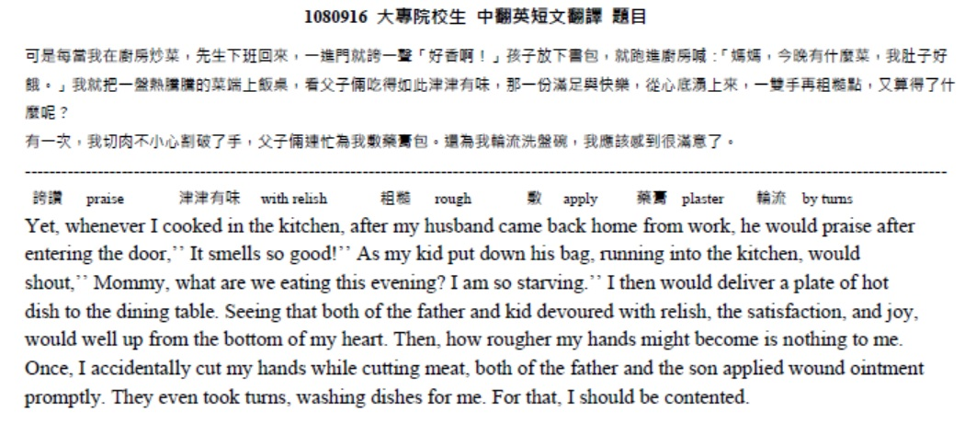
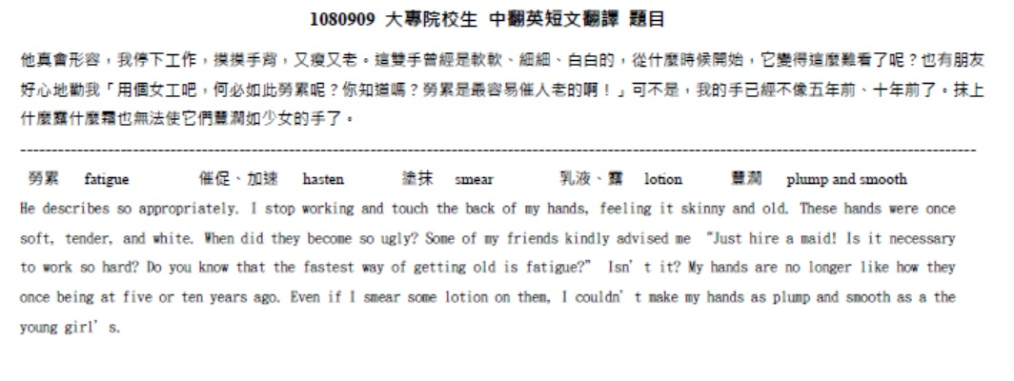
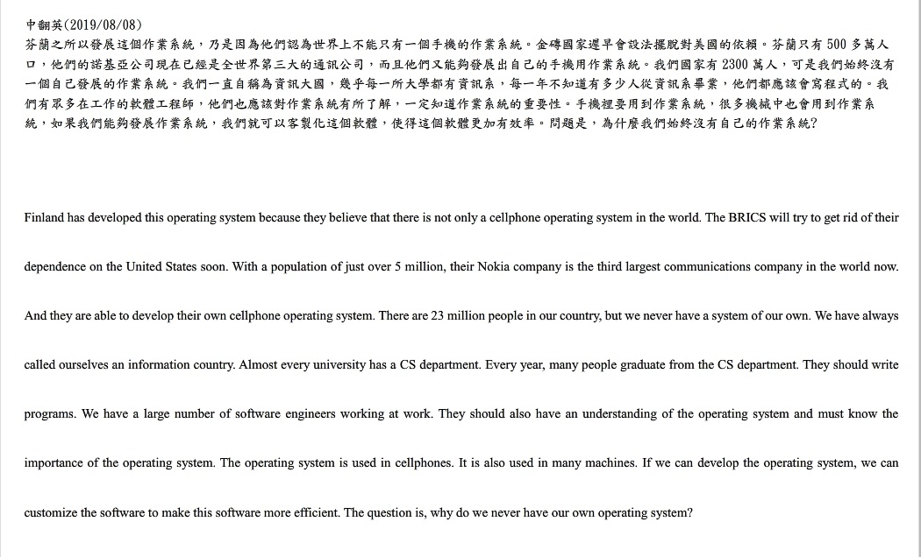
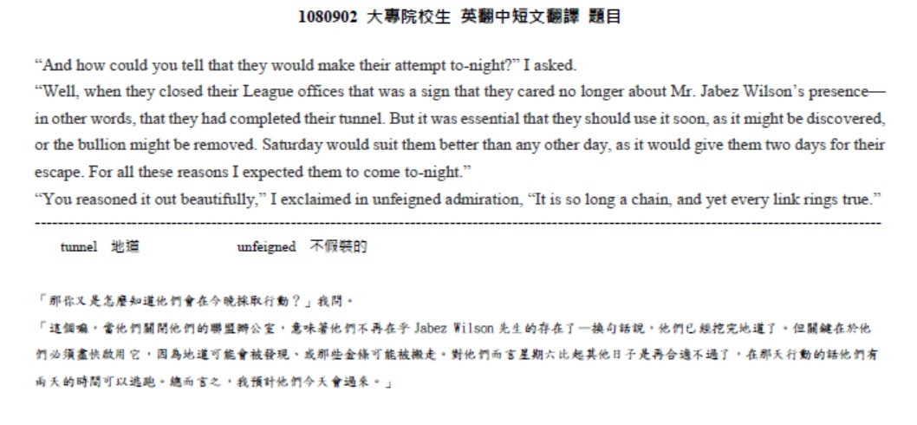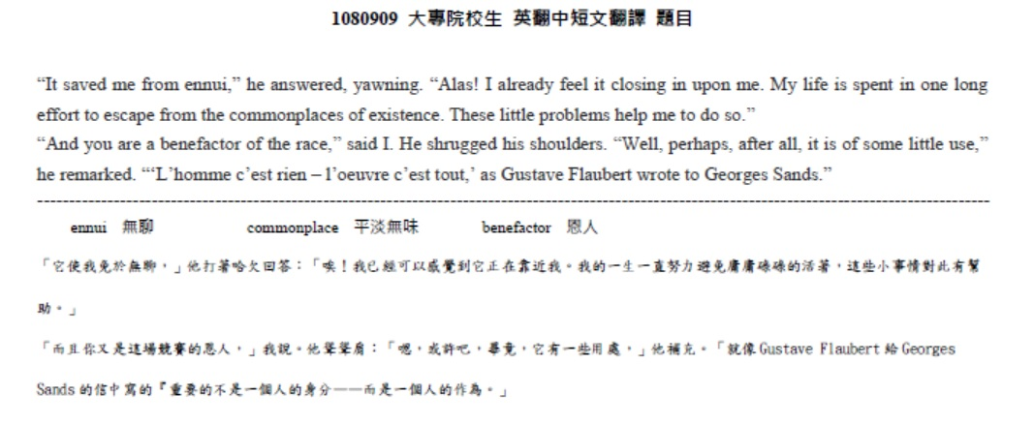

最後，我還是要說，很多大學生的英文程度是非常差的，請看以下的英文句子，這些都是一所國立大學工學院學生所寫出來的句子。
- Your brother had been eaten two apples.
- He begin play piano.
- Can he swimming?
- Did he had many books?
- Does you see?
- Do they jumping?
- Does she likes
- They are not take a nap now.
- He should walks
- She always a teacher.
- Does she calling her mother?
- He had ate
- Had he being many books.
- You can walk one hour help to sleep well.
- Do them daughter want
- So math not good.
- I have went there many times.
- He has been ate two apples.
- Was he have many books?
- He should walking.
- My brother likes paly.
- Does she a nurse?
- He eat two apples before.
- Swim is interesting.
- Does he has
- Do you seen
- Has he have
- Does he can swim
- He didn’t studying.
- Is he call his friend?

